

Specification

for

Ole Automation – Out Of Proc

SQLdm Project Marfa

Shekhar Vaidya

11/15/2007



Proprietary and Confidential to BBS Technologies, Inc.

© 2006 BBS Technologies, Inc.; all rights reserved.

Revision history:
When? | Who? | What?
3/11/2008 | Shekhar | Initial document – based on earlier proposal for implementing this feature.

Table of Contents
1. Revision history: ii
2. Table of Contents iii
3. Requirements 1
3.1. Overview/Purpose 1
3.1.1. Related Customer Requests 1
3.2. Target Users 1
3.3. Feature/Function Market Requirements 1
3.3.1. Required Functions 1
3.3.2. Non-Supported Functions 2
4. Functional Design 2
4.1. User Interfaces 2
4.2. Installation and Upgrade 3
4.3. Permissions and other Required Configuration 3
4.4. Licensing Issues 3
4.5. Dependencies 3
5. Internal Design 3
5.1. Architecture 3
5.1.1. Repository 3
5.1.2. Management Service 4
5.1.3. Collection Service 4
5.1.4. Desktop Client 4
5.2. Installation Issues 4
5.3. Schedule 4
6. Quality Assurance Considerations 5
6.1.1. Overview 5
6.1.2. Developer-Created Unit Tests 5
7. Documentation Considerations 5
8. Bibliography 5

Requirements

Overview/Purpose
SQLdm uses the SQL Server OLE Automation procedures (known as sp_OA procedures) to collect certain data. In response to a number of support cases where SQLdm’s use of these procedures has been called into question as a contributing factor to server instability.

This feature will allow a customer to configure SQLdm so that it executes Ole Automation queries outside the SQL Server memory space.

Related Customer Requests
Several customer related issues.

Target Users
Customers who are experiencing stability issues with their monitored SQL Servers, and use of in-process Ole Automation by SQLdm is suspected.

Feature/Function Market Requirements

Required Functions

Specify servers for out of proc Ole Automation
The customer can specify which monitored SQL Servers SQLdm should run its Ole Automation queries out of process. This is done by running a SQL script to update the SQLdm Repository and re-starting the Management Service.

Include sample scripts in the installation
Include the sample SQL script for configuring servers and also the registry file needed to setup COM components on the monitored SQL Server in the installation.

Add manual setup process to SQLdm documentation
SQLdm product documentation will provide steps for manually setting up servers for running Ole Automation out of process.

Non-Supported Functions

Desktop client support to specify servers
The UI does not support specifying servers for running Ole Automation out of process. The customer will have to run a database script to specify such servers.

Configuring COM registry settings
SQLdm uses WMI and FileSystemObject COM components in the Ole Automation queries. To run these out of process the surrogate process has to be specified. The customer has to manually set this up, SQLdm will not configure this automatically.

Functional Design

User Interfaces
If COM settings are not changed on the “out-of-process Ole Automation” servers then WMI and FileSystemObject data will not be available. The Overview->Dashboard and Databases->Files->Disks views will show a message that will indicate that some information is missing. When the customer clicks on the links the help will provide more information.
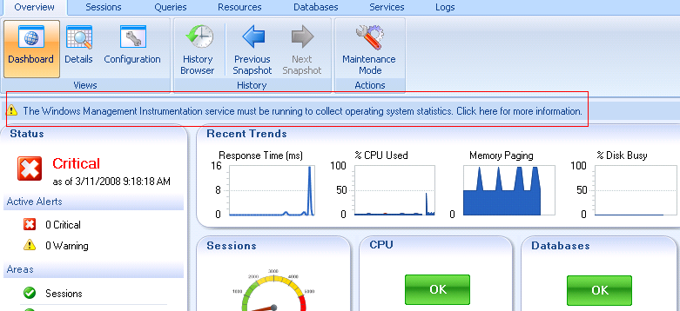
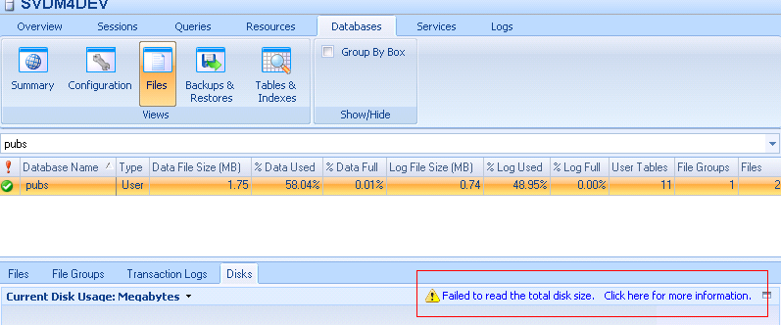

Installation and Upgrade
All components, including the repository, will require an upgrade. There are no special installation issues for this feature beyond a standard upgrade.

Permissions and other Required Configuration
The following manual steps have to be performed for configuring SQLdm, so that it runs Ole Automation queries out of process for the specified servers.
- Configure SQLdm Repository
  - Modify the T-SQL script SetMonitoredSQLServerOleAutomationOutOfProcess.sql, to identify the servers for which Ole Automation should be run out of process. This script is available on SQLdm CD image, Scripts folder.
  - Run the script on the SQLdm Repository
- Run the registry file SQLdmOutOfProcOleAutomation.reg on the servers specified in Step 1.
- Restart the SQLdm services, first the Management Service and then the Collection Service.

Licensing Issues
There are no licensing issues related to this feature.

Dependencies
No additional dependencies.

Internal Design

Architecture
Initially the plan was to extend the Management Service configuration file to specify servers to run Ole Automation out of process. However while testing it was recognized that modifying the configuration XML was error prone and would result in support calls. So this configuration option has been added to the Repository.

Repository
A new column, OutOfProcOleAutomation, has been added to the table MonitoredSQLServers in the SQLdm repository. The data type is bit, and is set to NULL on an upgrade. When this column is set to 1, it means that the customer wants to run Ole Automation out of process for this server.

Management Service
The Management Service sends the configuration setting for the monitored SQL Server to the Collection Service as part of the work load. This setting should be in the workload during startup, add a new server and modifying an existing server.

Collection Service
The following queries were modified to support out of process setting:
OSMetrics.sql
ServerOverview2000.sql
ServerOverview2005.sql
Services2000.sql
Services2005.sql
ServerBasics2000.sql
ServerBasics2005.sql
AgentJobSummary.sql
DiskDrives.sql
FullTextSearchService2000.sql
FullTextSearchService2005.sql
DTCStatus.sql
CustomCounterOS.sql

The probes associated with these queries were also modified to pass the Ole Automation context setting.

Desktop Client
The Databases->Files->Disks view was modified to add a label when the real-time collection is unable to collect data from the FileSystemObject COM component.

Installation Issues
Added the following files to the Scripts folder in the CD image:
- SetMonitoredSQLServerOleAutomationOutOfProcess.sql
- SQLdmOutOfProcOleAutomation.reg

Schedule
Scheduled for 5.5 3/11 drop.

Quality Assurance Considerations

Overview
- Upgrade from 5.0 should add the new column OutOfProcOleAutomation to the MonitoredSQLServers table in the Repository.
- Test that the OleAutomation setting is sent to the Collection Service by the Management Service (this can be verified by looking at the diagnostic logs), when:
  - During service startups.
  - Adding a new server.
  - Modifying a server.
- Test the desktop client behavior when COM settings have not been made on the server. Make sure that the help links show up and they contain appropriate information.

Developer-Created Unit Tests
None identified.

Documentation Considerations
- Update help topic Enable OS Metrics Monitoring to mention the need to run the reg file when out of process Ole Automation is selected.
- Update help topic Analyze Database Files->Get Disk Information to mention the need to run the reg file when out of process Ole Automation is selected.
- Update help to include manual steps for setting up Ole Automation out of process.

Bibliography

